# Appendix

## Queries

### Data Cleaning

Mobile_Game_Inapp_Purchases Dataset

# Check nulls per column

SELECT

COUNT(*) AS total_rows,

COUNTIF(Customer_ID IS NULL) AS null_customer_id,

COUNTIF(Device IS NULL) AS null_device,

COUNTIF(GameGenre IS NULL) AS null_game_genre,

COUNTIF(SessionCount IS NULL) AS null_session_count,

COUNTIF(AverageSessionLength IS NULL) AS null_average_session_length,

COUNTIF(SpendingSegment IS NULL) AS null_spending_segment,

COUNTIF(InAppPurchaseAmount IS NULL) AS null_in_app_purchase_amount,

COUNTIF(FirstPurchaseDaysAfterInstall IS NULL) AS null_fpadi,

COUNTIF(PaymentMethod IS NULL) AS null_payment_method,

COUNTIF(LastPurchaseDate IS NULL) AS null_purchase_date

FROM `mis784t22025-466123.MIS784_A3.Mobile_Game_Inapp_Purchases_A3`;

# Initial inspection shows that Device and GameGenre have 60 null values each. InAppPurcahseAmount, FirstPurchaseDaysAfterInstall, PaymentMethod, and LastPurchaseDate have 136 null values each => this makes sense becasue if the customers don't purchase anything then there's no records of these 4 variables.



# Create cleaned table

CREATE OR REPLACE TABLE `mis784t22025-466123.MIS784_A3.Mobile_Game_Inapp_Purchases_Cleaned` AS

SELECT

Customer_ID,

IFNULL(Device, "Unknown") AS Device,

IFNULL(GameGenre, "Unknown") AS GameGenre,

IFNULL(SessionCount, 0) AS SessionCount,

IFNULL(AverageSessionLength, 0.0) AS AverageSessionLength,

IFNULL(SpendingSegment, "Unknown") AS SpendingSegment,

IFNULL(InAppPurchaseAmount, 0.0) AS InAppPurchaseAmount,

IFNULL(FirstPurchaseDaysAfterInstall, 0) AS FirstPurchaseDaysAfterInstall,

IFNULL(PaymentMethod, "Not Applicable") AS PaymentMethod,

LastPurchaseDate,

CASE

WHEN LastPurchaseDate IS NULL THEN "No Purchase"

ELSE "Has Purchased"

END AS PurchaseStatus

FROM `mis784t22025-466123.MIS784_A3.Mobile_Game_Inapp_Purchases_A3`;

### Donor Behaviour Patterns

Traditional Donor Monetary Contribution

# Monetary Contribution

SELECT

MIN(DonationAmount) AS min_value,

ROUND(APPROX_QUANTILES(DonationAmount, 4)[OFFSET(1)],2) AS q1,

ROUND(APPROX_QUANTILES(DonationAmount, 2)[OFFSET(1)],2) AS median,

ROUND(APPROX_QUANTILES(DonationAmount, 4)[OFFSET(3)],2) AS q3,

MAX(DonationAmount) AS max_value,

ROUND(AVG(DonationAmount),2) AS avg_value,

-- IQR = Q3 - Q1

ROUND(

APPROX_QUANTILES(DonationAmount, 4)[OFFSET(3)]

- APPROX_QUANTILES(DonationAmount, 4)[OFFSET(1)],2

) AS iqr

FROM `mis784t22025-466123.MIS784_A3.Tradition_Donation_Patterns_A3`;

**Results**



# Monetary Contribution by product type

SELECT

Product,

MIN(DonationAmount) AS min_value,

ROUND(APPROX_QUANTILES(DonationAmount, 4)[OFFSET(1)],2) AS q1,

ROUND(APPROX_QUANTILES(DonationAmount, 2)[OFFSET(1)],2) AS median,

ROUND(APPROX_QUANTILES(DonationAmount, 4)[OFFSET(3)],2) AS q3,

MAX(DonationAmount) AS max_value,

ROUND(AVG(DonationAmount),2) AS avg_value,

ROUND(

APPROX_QUANTILES(DonationAmount, 4)[OFFSET(3)]

- APPROX_QUANTILES(DonationAmount, 4)[OFFSET(1)],2

) AS iqr

FROM `mis784t22025-466123.MIS784_A3.Tradition_Donation_Patterns_A3`

GROUP BY Product

ORDER BY Product;

**Results**

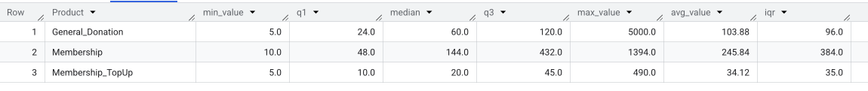

# Exploring top 10% Contribution Share

WITH donor_totals AS (

SELECT

Customer_ID,

SUM(DonationAmount) AS total_donated

FROM `mis784t22025-466123.MIS784_A3.Tradition_Donation_Patterns_A3`

GROUP BY Customer_ID

),

ranked AS (

SELECT

total_donated,

NTILE(10) OVER (ORDER BY total_donated DESC) AS decile

FROM donor_totals

)

SELECT

ROUND(SUM(CASE WHEN decile = 1 THEN total_donated ELSE 0 END) / SUM(total_donated) * 100,2) AS top10_pct_share

FROM ranked;

**Results**

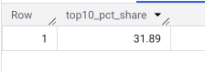

In-app Monetary Contribution

# Monetary Contribution

SELECT

MIN(InAppPurchaseAmount) AS min_value,

ROUND(APPROX_QUANTILES(InAppPurchaseAmount, 4)[OFFSET(1)],2) AS q1,

ROUND(APPROX_QUANTILES(InAppPurchaseAmount, 2)[OFFSET(1)],2) AS median,

ROUND(APPROX_QUANTILES(InAppPurchaseAmount, 4)[OFFSET(3)],2) AS q3,

MAX(InAppPurchaseAmount) AS max_value,

ROUND(AVG(InAppPurchaseAmount),2) AS avg_value,

-- IQR = Q3 - Q1

ROUND(

APPROX_QUANTILES(InAppPurchaseAmount, 4)[OFFSET(3)]

- APPROX_QUANTILES(InAppPurchaseAmount, 4)[OFFSET(1)],2

) AS iqr

FROM `mis784t22025-466123.MIS784_A3.Mobile_Game_Inapp_Purchases_No_Nulls`;

**Results**



# Monetary Contribution by Spending Segment

SELECT

MIN(InAppPurchaseAmount) AS min_value,

ROUND(APPROX_QUANTILES(InAppPurchaseAmount, 4)[OFFSET(1)],2) AS q1,

ROUND(APPROX_QUANTILES(InAppPurchaseAmount, 2)[OFFSET(1)],2) AS median,

ROUND(APPROX_QUANTILES(InAppPurchaseAmount, 4)[OFFSET(3)],2) AS q3,

MAX(InAppPurchaseAmount) AS max_value,

ROUND(AVG(InAppPurchaseAmount),2) AS avg_value,

-- IQR = Q3 - Q1

ROUND(

APPROX_QUANTILES(InAppPurchaseAmount, 4)[OFFSET(3)]

- APPROX_QUANTILES(InAppPurchaseAmount, 4)[OFFSET(1)],2

) AS iqr

FROM `mis784t22025-466123.MIS784_A3.Mobile_Game_Inapp_Purchases_No_Nulls`;

**Results**

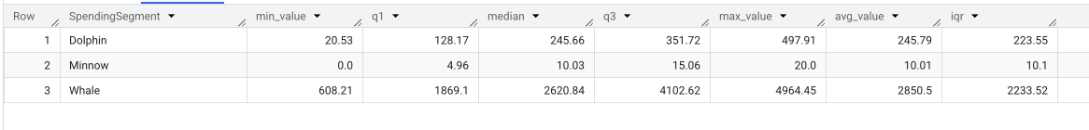

# Exploring top 10% Contribution Share

WITH ranked AS (

SELECT

InAppPurchaseAmount AS total_donated,

NTILE(10) OVER (ORDER BY InAppPurchaseAmount DESC) AS decile

FROM `mis784t22025-466123.MIS784_A3.Mobile_Game_Inapp_Purchases_No_Nulls`

)

SELECT

ROUND(SUM(CASE WHEN decile = 1 THEN total_donated ELSE 0 END) / SUM(total_donated) * 100,2) AS top10_pct_share

FROM ranked;

**Results**

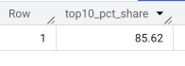

RFM Segmemtation

Traditional Donor Payment Methods

SELECT

Channel_Pay,

COUNT(*) AS frequency,

ROUND(COUNT(*) * 100.0 / SUM(COUNT(*)) OVER(),2) AS pct

FROM `mis784t22025-466123.MIS784_A3.Tradition_Donation_Patterns_A3`

GROUP BY Channel_Pay

ORDER BY frequency DESC;

**Results**

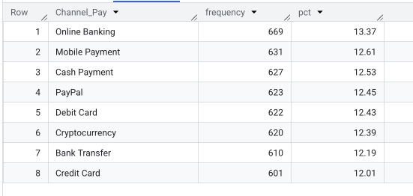

In-app Payment Methods

SELECT

PaymentMethod,

COUNT(*) AS frequency,

ROUND(COUNT(*) * 100.0 / SUM(COUNT(*)) OVER(),2) AS pct

FROM `mis784t22025-466123.MIS784_A3.Mobile_Game_Inapp_Purchases_No_Nulls`

GROUP BY PaymentMethod

ORDER BY frequency DESC;

**Results**

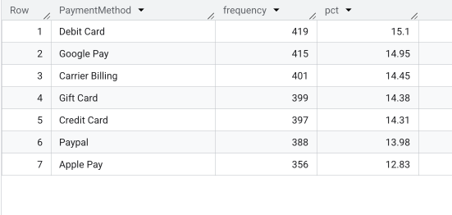

Traditional Donor Frequency

# Overall Frequency

WITH donor_freq AS (

SELECT

Customer_ID,

COUNT(Donation_ID) AS donation_count

FROM `mis784t22025-466123.MIS784_A3.Tradition_Donation_Patterns_A3`

GROUP BY Customer_ID

)

SELECT

COUNT(*) AS total_donors,

ROUND(AVG(donation_count),2) AS avg_donations,

APPROX_QUANTILES(donation_count, 2)[OFFSET(1)] AS median_donations,

ROUND(SUM(CASE WHEN donation_count=1 THEN 1 ELSE 0 END)*100.0/COUNT(*),2) AS pct_one_time_donors,

ROUND(SUM(CASE WHEN donation_count>1 THEN 1 ELSE 0 END)*100.0/COUNT(*),2) AS pct_repeat_donors

FROM donor_freq;

**Results**

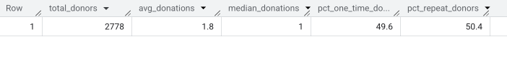

# Frequency segment

WITH donor_freq AS (

SELECT

Customer_ID,

COUNT(Donation_ID) AS donation_count

FROM `mis784t22025-466123.MIS784_A3.Tradition_Donation_Patterns_A3`

GROUP BY Customer_ID

),

freq_with_customer AS (

SELECT

c.Customer_ID,

c.Age,

c.Gender,

c.Family_Size,

f.donation_count

FROM donor_freq f

JOIN `mis784t22025-466123.MIS784_A3.customer_A3` c

ON f.Customer_ID = c.Customer_ID

),

freq_with_agegroup AS (

SELECT *,

CASE

WHEN Age < 30 THEN 'Under 30'

WHEN Age BETWEEN 30 AND 44 THEN '30–44'

WHEN Age BETWEEN 45 AND 59 THEN '45–59'

ELSE '60+'

END AS Age_Group

FROM freq_with_customer

)

SELECT

Age_Group,

CASE

WHEN donation_count = 1 THEN 'One-time'

WHEN donation_count BETWEEN 2 AND 4 THEN 'Occasional (2–4)'

ELSE 'Frequent (5+)'

END AS frequency_segment,

COUNT(*) AS donor_count,

ROUND(100 * COUNT(*) / SUM(COUNT(*)) OVER (PARTITION BY Age_Group), 1) AS pct_within_age_group

FROM freq_with_agegroup

GROUP BY Age_Group, frequency_segment

ORDER BY Age_Group, frequency_segment;

**Results**

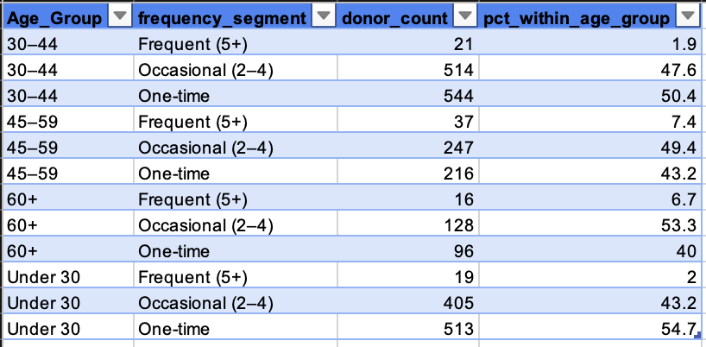

Traditional Donor Recency

# Overall recency

WITH donor_recency AS (

SELECT

Customer_ID,

MAX(DonationDate) AS last_donation

FROM `mis784t22025-466123.MIS784_A3.Tradition_Donation_Patterns_A3`

GROUP BY Customer_ID

),

max_date AS (

SELECT MAX(DonationDate) AS dataset_max_date

FROM `mis784t22025-466123.MIS784_A3.Tradition_Donation_Patterns_A3`

)

SELECT

ROUND(AVG(DATE_DIFF(m.dataset_max_date, r.last_donation, DAY)),1) AS avg_days_since,

APPROX_QUANTILES(DATE_DIFF(m.dataset_max_date, r.last_donation, DAY), 2)[OFFSET(1)] AS median_days_since,

ROUND(100*AVG(CAST(DATE_DIFF(m.dataset_max_date, r.last_donation, DAY) > 90 AS INT64)),2) AS pct_inactive_90d,

ROUND(100*AVG(CAST(DATE_DIFF(m.dataset_max_date, r.last_donation, DAY) > 180 AS INT64)),2) AS pct_inactive_180d

FROM donor_recency r

CROSS JOIN max_date m;

**Results**

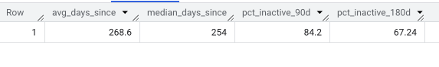

# Recency segments

WITH donor_recency AS (

SELECT

Customer_ID,

MAX(DonationDate) AS last_donation

FROM `mis784t22025-466123.MIS784_A3.Tradition_Donation_Patterns_A3`

GROUP BY Customer_ID

),

max_date AS (

SELECT MAX(DonationDate) AS dataset_max_date

FROM `mis784t22025-466123.MIS784_A3.Tradition_Donation_Patterns_A3`

),

recency_segmented AS (

SELECT

c.Customer_ID,

c.Age,

c.Family_Size,

c.Gender,

r.last_donation,

DATE_DIFF(m.dataset_max_date, r.last_donation, DAY) AS days_since_last,

CASE

WHEN DATE_DIFF(m.dataset_max_date, r.last_donation, DAY) <= 90 THEN 'Active (≤90d)'

WHEN DATE_DIFF(m.dataset_max_date, r.last_donation, DAY) <= 180 THEN 'At Risk (91–180d)'

ELSE 'Lapsed (>180d)'

END AS recency_segment

FROM donor_recency r

JOIN `mis784t22025-466123.MIS784_A3.customer_A3` c

ON r.Customer_ID = c.Customer_ID

CROSS JOIN max_date m

),

recency_with_agegroup AS (

SELECT *,

CASE

WHEN Age < 30 THEN 'Under 30'

WHEN Age BETWEEN 30 AND 44 THEN '30–44'

WHEN Age BETWEEN 45 AND 59 THEN '45–59'

ELSE '60+'

END AS Age_Group

FROM recency_segmented

)

SELECT

Age_Group,

recency_segment,

COUNT(*) AS donor_count,

ROUND(100 * COUNT(*) / SUM(COUNT(*)) OVER (PARTITION BY Age_Group), 1) AS pct_within_age_group

FROM recency_with_agegroup

GROUP BY Age_Group, recency_segment

ORDER BY Age_Group, recency_segment;

**Results**

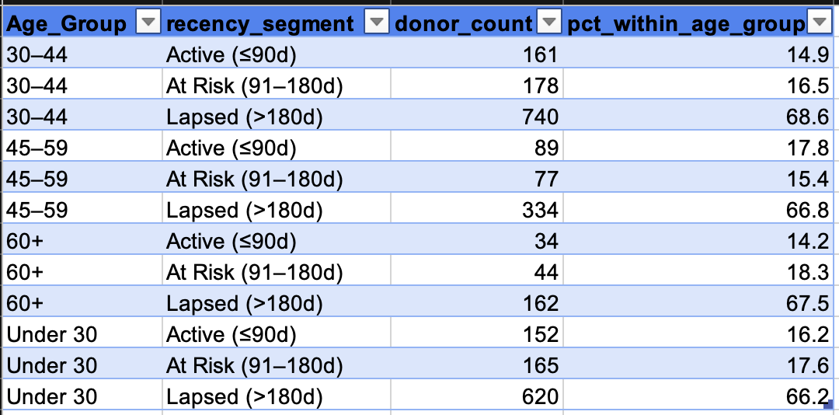

In-app Engagement

# Engagement summary

SELECT

ROUND(AVG(SessionCount),1) AS avg_sessions,

APPROX_QUANTILES(SessionCount, 2)[OFFSET(1)] AS median_sessions,

ROUND(AVG(AverageSessionLength),1) AS avg_session_length,

APPROX_QUANTILES(AverageSessionLength, 2)[OFFSET(1)] AS median_session_length,

ROUND(AVG(FirstPurchaseDaysAfterInstall),1) AS avg_days_to_first_purchase,

APPROX_QUANTILES(FirstPurchaseDaysAfterInstall, 2)[OFFSET(1)] AS median_days_to_first_purchase

FROM `mis784t22025-466123.MIS784_A3.Mobile_Game_Inapp_Purchases_No_Nulls`;

**Results**



# Spending Segment Engagement Summary

SELECT

SpendingSegment,

ROUND(AVG(SessionCount),1) AS avg_sessions,

ROUND(AVG(AverageSessionLength),1) AS avg_session_length,

ROUND(AVG(InAppPurchaseAmount),2) AS avg_spend

FROM `mis784t22025-466123.MIS784_A3.Mobile_Game_Inapp_Purchases_No_Nulls`

GROUP BY SpendingSegment

ORDER BY avg_spend DESC;

**Results**

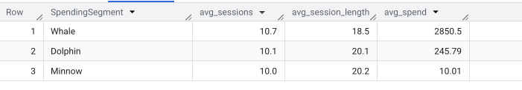

# Game Genre choice per Spending Segment

SELECT

SpendingSegment,

GameGenre,

COUNT(*) AS donor_count

FROM `mis784t22025-466123.MIS784_A3.Mobile_Game_Inapp_Purchases_No_Nulls`

GROUP BY SpendingSegment, GameGenre

ORDER BY SpendingSegment, donor_count DESC;

**Results**

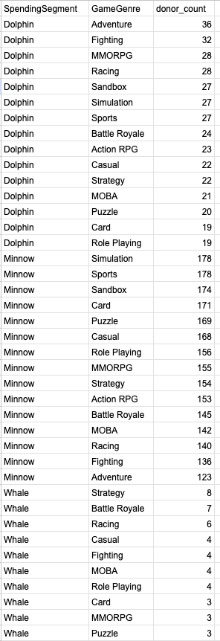

### Churn Risk & Retention

**1.** **Data Check for Nulls:**

**Query:**

SELECT

COUNTIF(Customer_ID IS NULL) AS null_customer,

COUNTIF(Donation_ID IS NULL) AS null_donation,

COUNTIF(DonationDate IS NULL) AS null_donationdate,

COUNTIF(DonationEndDate IS NULL) AS null_donationenddate,

COUNTIF(DonationAmount IS NULL) AS null_amount,

COUNTIF(Product IS NULL) AS null_product,

COUNTIF(Channel_Pay IS NULL) AS null_channel

FROM `mis784-sem1.Assignment_3.Tradition_Donation_Patterns`;

**Result:**



**Query:**

SELECT

COUNTIF(Customer_ID IS NULL) AS null_customer,

COUNTIF(LastPurchaseDate IS NULL) AS null_lastpurchase,

COUNTIF(SessionCount IS NULL) AS null_sessioncount,

COUNTIF(AverageSessionLength IS NULL) AS null_avgsessionlength,

COUNTIF(SpendingSegment IS NULL) AS null_segment,

COUNTIF(PaymentMethod IS NULL) AS null_payment,

COUNTIF(InAppPurchaseAmount IS NULL) AS null_inapppurchase

FROM `mis784-sem1.Assignment_3.Mobile_Game_Inapp_Purchases`;

**Result:**



**Query:**

SELECT

COUNTIF(Customer_ID IS NULL) AS null_customer,

COUNTIF(Campaign_ID IS NULL) AS null_campaign,

COUNTIF(Response IS NULL) AS null_response,

COUNTIF(ClickThroughRate IS NULL) AS null_ctr,

COUNTIF(EngagementFrequency IS NULL) AS null_engagement

FROM `mis784-sem1.Assignment_3.Campaign_Response`;

**Result:**



**Query**:

SELECT

COUNTIF(Customer_ID IS NULL) AS null_customer,

COUNTIF(Age IS NULL) AS null_age,

COUNTIF(Gender IS NULL) AS null_gender,

COUNTIF(Occupation IS NULL) AS null_occupation,

COUNTIF(Income_Level IS NULL) AS null_incomelevel,

COUNTIF(Location IS NULL) AS null_location,

COUNTIF(City IS NULL) AS null_city,

COUNTIF(Family_Size IS NULL) AS null_familysize

FROM `mis784-sem1.Assignment_3.Customers`;

**Result**:



**2.** **Duplicates check:**

**Query:**

SELECT COUNT(*) AS total_rows,

COUNT(DISTINCT Donation_ID) AS unique_donation_ids

FROM `mis784-sem1.Assignment_3.Tradition_Donation_Patterns`;

**Result:**



**NOTE:** Says there are 5003 unique donations made.

**Query:**

SELECT Customer_ID, DonationDate, COUNT(*) AS dup_cnt

FROM `mis784-sem1.Assignment_3.Tradition_Donation_Patterns`

GROUP BY Customer_ID, DonationDate

HAVING COUNT(*) > 1;

**Result:**

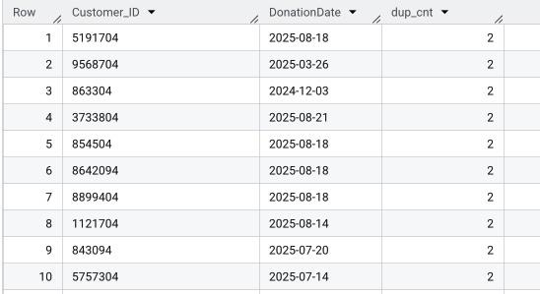

**NOTE:** However, checking as per Customer_ID and DonationDate, some donors are appearing two times (dup_cnt=2), which means they donated multiple times on the same date. These duplicates were not removed in order to maintain accurate donation patterns, because they represent actual separate donations, not data errors.

**Query:**

SELECT Customer_ID, LastPurchaseDate, COUNT(*) AS dup_cnt

FROM `mis784-sem1.Assignment_3.Mobile_Game_Inapp_Purchases`

GROUP BY Customer_ID, LastPurchaseDate

HAVING COUNT(*) > 1;

**Result:**

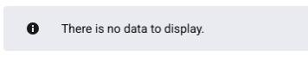

**NOTE:** Hence no duplicate data.

**Query:**

SELECT Customer_ID, Campaign_ID, COUNT(*) AS dup_cnt

FROM `mis784-sem1.Assignment_3.Campaign_Response`

GROUP BY Customer_ID, Campaign_ID

HAVING COUNT(*) > 1;

**Result:**

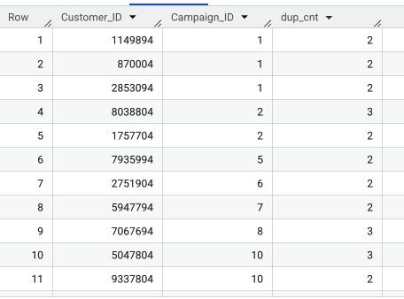

**3.** **Outliers Check:**

**Query:**

SELECT

APPROX_QUANTILES(DonationAmount, 100) AS donation_amount_quantiles,

APPROX_QUANTILES(DATE_DIFF(DonationEndDate, DonationDate, DAY), 100) AS duration_quantiles

FROM `mis784-sem1.Assignment_3.Tradition_Donation_Patterns`;

**Result:**

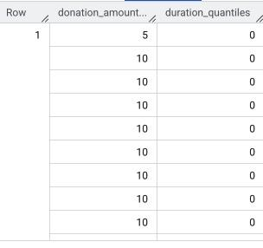

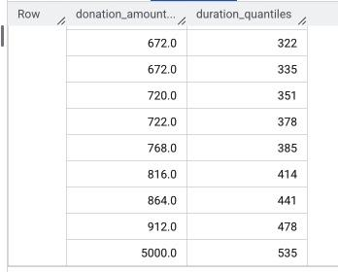

**Query:**

SELECT

APPROX_QUANTILES(SessionCount, 100) AS session_count_quantiles,

APPROX_QUANTILES(AverageSessionLength, 100) AS session_length_quantiles,

APPROX_QUANTILES(InAppPurchaseAmount, 100) AS purchase_amount_quantiles

FROM `mis784-sem1.Assignment_3.Mobile_Game_Inapp_Purchases`;

**Result:**

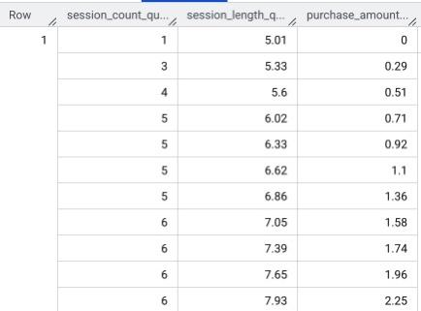

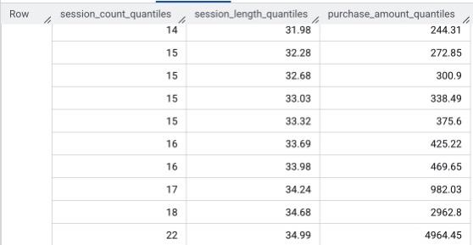

**Query:**

SELECT

APPROX_QUANTILES(ClickThroughRate, 100) AS ctr_quantiles,

APPROX_QUANTILES(EngagementFrequency, 100) AS engagement_quantiles

FROM `mis784-sem1.Assignment_3.Campaign_Response`;

**Result:**

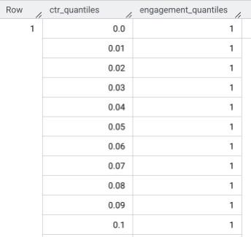

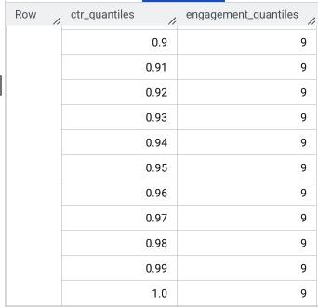

**Result**:

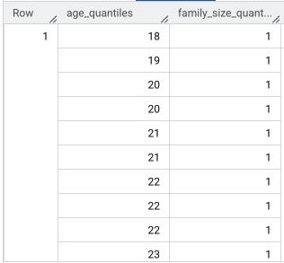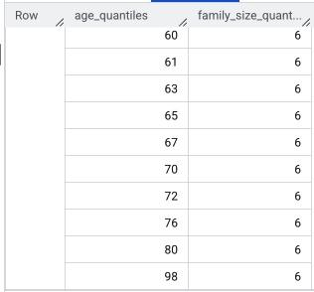

**4.** **Unified RFM Analysis (Create Views)**

**5. RFM Segment Counts**

**Query:**

SELECT donation_rfm_segment AS segment, COUNT(*) AS donor_count

FROM `mis784-sem1.Assignment_3.v_donation_segment`

GROUP BY segment

ORDER BY donor_count DESC;

**Result:**

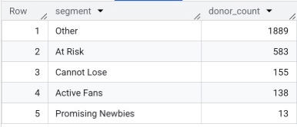

**Query:**

SELECT inapp_rfm_segment AS segment, COUNT(*) AS donor_count

FROM `mis784-sem1.Assignment_3.v_inapp_segment`

GROUP BY segment

ORDER BY donor_count DESC;

**Result:**



**6.** **Campaign Response by Churn Segment (Traditional & In-App):**

**a)** **Campaign Response Rate by Churn Segment – Traditional Donors**

**Query:**

WITH seg AS (

SELECT CAST(Customer_ID AS STRING) AS customer_id_s,

donation_rfm_segment AS churn_segment

FROM `mis784-sem1.Assignment_3.v_donation_segment`

),

camp AS (

SELECT

CAST(Customer_ID AS STRING) AS customer_id_s,

CASE

WHEN SAFE_CAST(Response AS BOOL) IS NOT NULL THEN SAFE_CAST(Response AS BOOL)

WHEN LOWER(CAST(Response AS STRING)) IN ('yes','y','true','1') THEN TRUE

WHEN LOWER(CAST(Response AS STRING)) IN ('no','n','false','0') THEN FALSE

ELSE FALSE

END AS responded_flag

FROM `mis784-sem1.Assignment_3.Campaign_Response`

),

customer_level AS (

SELECT s.churn_segment,

c.customer_id_s,

MAX(c.responded_flag) AS any_response

FROM seg s

JOIN camp c USING (customer_id_s)

GROUP BY s.churn_segment, c.customer_id_s

)

SELECT

churn_segment,

COUNT(*) AS total_customers,

SUM(CASE WHEN any_response THEN 1 ELSE 0 END) AS responders,

ROUND(100.0 * SUM(CASE WHEN any_response THEN 1 ELSE 0 END) / COUNT(*), 2) AS response_rate_pct

FROM customer_level

GROUP BY churn_segment

ORDER BY response_rate_pct DESC;

**Result:**

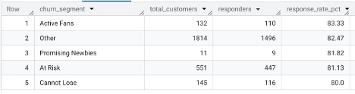

**b)** **Campaign Response Rate by Churn Segment – Mobile In-App**

**Query:**

WITH seg AS (

SELECT CAST(Customer_ID AS STRING) AS customer_id_s,

inapp_rfm_segment AS churn_segment

FROM `mis784-sem1.Assignment_3.v_inapp_segment`

),

camp AS (

SELECT

CAST(Customer_ID AS STRING) AS customer_id_s,

CASE

WHEN SAFE_CAST(Response AS BOOL) IS NOT NULL THEN SAFE_CAST(Response AS BOOL)

WHEN LOWER(CAST(Response AS STRING)) IN ('yes','y','true','1') THEN TRUE

WHEN LOWER(CAST(Response AS STRING)) IN ('no','n','false','0') THEN FALSE

ELSE FALSE

END AS responded_flag

FROM `mis784-sem1.Assignment_3.Campaign_Response`

),

customer_level AS (

SELECT s.churn_segment, c.customer_id_s, MAX(c.responded_flag) AS any_response

FROM seg s

JOIN camp c USING (customer_id_s)

GROUP BY s.churn_segment, c.customer_id_s

)

SELECT

churn_segment,

COUNT(*) AS total_customers,

SUM(CASE WHEN any_response THEN 1 ELSE 0 END) AS responders,

ROUND(100.0 * SUM(CASE WHEN any_response THEN 1 ELSE 0 END) / COUNT(*), 2) AS response_rate_pct

FROM customer_level

GROUP BY churn_segment

ORDER BY response_rate_pct DESC;

**Result:**

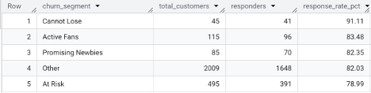

**c)** **Click-Through & Engagement by Churn Segment – Traditional Donors**

**Query:**

WITH customer_avg AS (

SELECT

ds.donation_rfm_segment AS churn_segment,

cr.Customer_ID,

AVG(SAFE_CAST(cr.ClickThroughRate AS FLOAT64)) AS customer_avg_ctr,

AVG(SAFE_CAST(cr.EngagementFrequency AS FLOAT64)) AS customer_avg_engagement

FROM `mis784-sem1.Assignment_3.Campaign_Response` cr

JOIN `mis784-sem1.Assignment_3.v_donation_segment` ds

ON CAST(cr.Customer_ID AS STRING) = CAST(ds.Customer_ID AS STRING)

WHERE cr.ClickThroughRate IS NOT NULL

AND cr.EngagementFrequency IS NOT NULL

GROUP BY churn_segment, cr.Customer_ID

)

SELECT

churn_segment,

ROUND(AVG(customer_avg_ctr) * 100.0, 2) AS ctr_pct_customer_avg,

ROUND(AVG(customer_avg_engagement), 2) AS eng_freq_customer_avg,

COUNT(DISTINCT Customer_ID) AS customers_count

FROM customer_avg

GROUP BY churn_segment

ORDER BY eng_freq_customer_avg DESC;

**Result:**

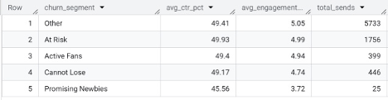

**d)** **Click-Through & Engagement by Churn Segment – In-App**

**Query:**

WITH customer_avg AS (

SELECT

ds.inapp_rfm_segment AS churn_segment,

cr.Customer_ID,

AVG(SAFE_CAST(cr.ClickThroughRate AS FLOAT64)) AS customer_avg_ctr,

AVG(SAFE_CAST(cr.EngagementFrequency AS FLOAT64)) AS customer_avg_engagement

FROM `mis784-sem1.Assignment_3.Campaign_Response` cr

JOIN `mis784-sem1.Assignment_3.v_inapp_segment` ds

ON CAST(cr.Customer_ID AS STRING) = CAST(ds.Customer_ID AS STRING)

WHERE cr.ClickThroughRate IS NOT NULL

AND cr.EngagementFrequency IS NOT NULL

GROUP BY churn_segment, cr.Customer_ID

)

SELECT

churn_segment,

ROUND(AVG(customer_avg_ctr) * 100.0, 2) AS ctr_pct_customer_avg,

ROUND(AVG(customer_avg_engagement), 2) AS eng_freq_customer_avg,

COUNT(DISTINCT Customer_ID) AS customers_count

FROM customer_avg

GROUP BY churn_segment

ORDER BY eng_freq_customer_avg DESC;

**Result:**

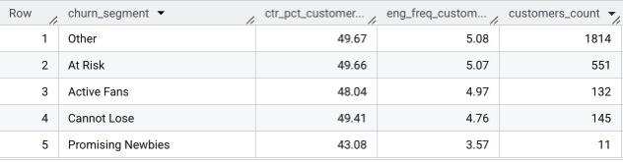

**7.** **Behavioral Predictors Attrition:**

**a)** **Outliers (Traditional Donors)**

**Query (Bottom Donors- Lowest Totals):**

SELECT

donation_total_amount,

COUNT(*) AS donor_count

FROM `mis784-sem1.Assignment_3.v_donation_agg`

GROUP BY donation_total_amount

ORDER BY donation_total_amount ASC

LIMIT 10;

**Result:**

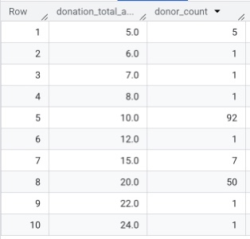

**Query (Top Donors- Highest Totals):**

SELECT

Customer_ID,

donation_total_amount,

donation_frequency,

days_since_last_donation

FROM `mis784-sem1.Assignment_3.v_donation_agg`

ORDER BY donation_total_amount DESC

LIMIT 10;

**Result:**

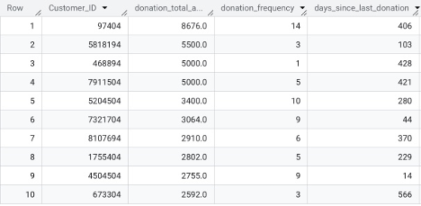

**b)** **Outliers (In-app)**

**Query (Bottom Donors- Lowest Totals):**

SELECT

purchase_total_amount,

COUNT(*) AS customer_count

FROM `mis784-sem1.Assignment_3.v_inapp_agg`

GROUP BY purchase_total_amount

ORDER BY purchase_total_amount ASC

LIMIT 10;

**Result:**

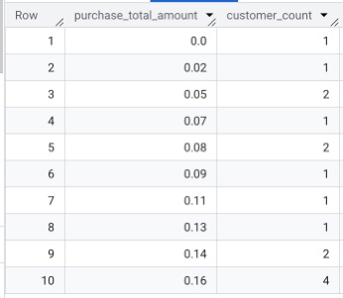

**Query (Top Donors- Highest Totals):**

SELECT

Customer_ID,

purchase_total_amount,

purchase_frequency,

days_since_last_purchase

FROM `mis784-sem1.Assignment_3.v_inapp_agg`

ORDER BY purchase_total_amount DESC

LIMIT 10;

**Result:**

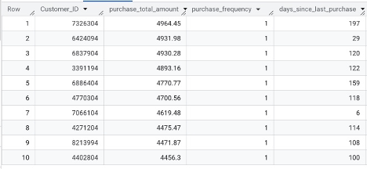

**c)** **RFM Drivers (Traditional Donors)**

**Query:**

SELECT

s.donation_rfm_segment AS churn_segment,

ROUND(AVG(a.days_since_last_donation), 1) AS avg_days_since_last,

ROUND(AVG(a.donation_frequency), 2) AS avg_frequency,

ROUND(AVG(a.donation_total_amount), 2) AS avg_total_donations,

COUNT(*) AS donors_in_segment

FROM `mis784-sem1.Assignment_3.v_donation_agg` a

JOIN `mis784-sem1.Assignment_3.v_donation_segment` s

ON a.Customer_ID = s.Customer_ID

GROUP BY churn_segment

ORDER BY avg_days_since_last DESC;

**Result:**

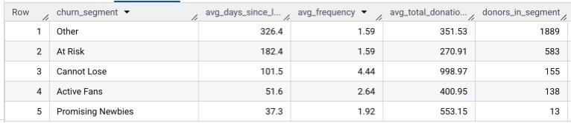

**c)** **RFM Drivers (In-App)**

**Query:**

SELECT

s.inapp_rfm_segment AS churn_segment,

ROUND(AVG(a.days_since_last_purchase), 1) AS avg_days_since_last,

ROUND(AVG(a.purchase_frequency), 2) AS avg_frequency,

ROUND(AVG(a.purchase_total_amount), 2) AS avg_total_purchases,

COUNT(*) AS customers_in_segment

FROM `mis784-sem1.Assignment_3.v_inapp_agg` a

JOIN `mis784-sem1.Assignment_3.v_inapp_segment` s

ON a.Customer_ID = s.Customer_ID

GROUP BY churn_segment

ORDER BY avg_days_since_last DESC;

**Result:**

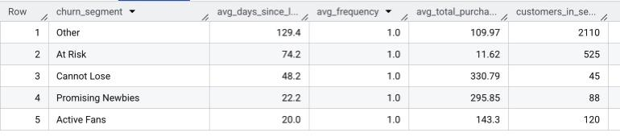

**d)** **Revenue Concentration by Top 10% vs Rest**

**Query:**

WITH trad_totals AS (

SELECT Customer_ID, SUM(DonationAmount) AS total_amt

FROM `mis784-sem1.Assignment_3.Tradition_Donation_Patterns`

WHERE DonationAmount IS NOT NULL

GROUP BY Customer_ID

),

trad_ranked AS (

SELECT

*,

NTILE(10) OVER (ORDER BY total_amt DESC) AS decile

FROM trad_totals

),

inapp_totals AS (

SELECT Customer_ID, SUM(IFNULL(InAppPurchaseAmount,0)) AS total_amt

FROM `mis784-sem1.Assignment_3.Mobile_Game_Inapp_Purchases`

GROUP BY Customer_ID

),

inapp_ranked AS (

SELECT

*,

NTILE(10) OVER (ORDER BY total_amt DESC) AS decile

FROM inapp_totals

)

-- Traditional

SELECT

'Traditional' AS channel,

ROUND(SUM(CASE WHEN decile = 1 THEN total_amt ELSE 0 END) / SUM(total_amt) * 100, 2) AS top10_share_pct,

ROUND(SUM(CASE WHEN decile <= 2 THEN total_amt ELSE 0 END) / SUM(total_amt) * 100, 2) AS top20_share_pct,

COUNT(*) AS donors_count

FROM trad_ranked

UNION ALL

-- In-App

SELECT

'In-App' AS channel,

ROUND(SUM(CASE WHEN decile = 1 THEN total_amt ELSE 0 END) / SUM(total_amt) * 100, 2) AS top10_share_pct,

ROUND(SUM(CASE WHEN decile <= 2 THEN total_amt ELSE 0 END) / SUM(total_amt) * 100, 2) AS top20_share_pct,

COUNT(*) AS customers_count

FROM inapp_ranked;

**Result:**

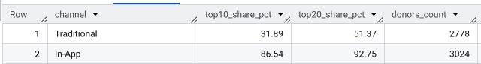

**8. Demographics Impact on Retention:**

1. **Age Distribution Across Churn Groups - Traditional Donors**

**Query:**

SELECT

ds.donation_rfm_segment AS churn_segment,

ROUND(AVG(c.Age), 1) AS avg_age,

MIN(c.Age) AS min_age,

MAX(c.Age) AS max_age,

COUNT(*) AS donors_in_segment

FROM `mis784-sem1.Assignment_3.v_donation_segment` ds

JOIN `mis784-sem1.Assignment_3.Customers` c

ON ds.Customer_ID = c.Customer_ID

GROUP BY churn_segment

ORDER BY avg_age;

**Result:**

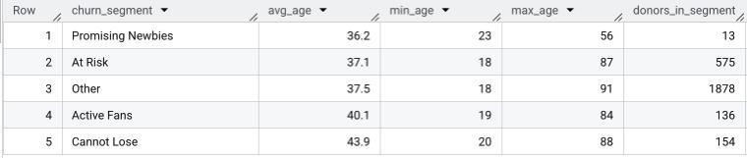

1. **Age Distribution Across Churn Groups - In-App**

**Query:**

SELECT

iseg.inapp_rfm_segment AS churn_segment,

ROUND(AVG(c.Age), 1) AS avg_age,

MIN(c.Age) AS min_age,

MAX(c.Age) AS max_age,

COUNT(*) AS customers_in_segment

FROM `mis784-sem1.Assignment_3.v_inapp_segment` iseg

JOIN `mis784-sem1.Assignment_3.Customers` c

ON iseg.Customer_ID = c.Customer_ID

GROUP BY churn_segment

ORDER BY avg_age;

**Result:**

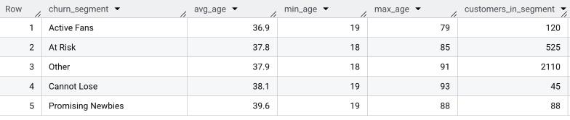

* + 1. **Gender vs Churn Segment - Traditional Donors**

**Query:**

SELECT

ds.donation_rfm_segment AS churn_segment,

c.Gender,

COUNT(*) AS donor_count

FROM `mis784-sem1.Assignment_3.v_donation_segment` ds

JOIN `mis784-sem1.Assignment_3.Customers` c

ON ds.Customer_ID = c.Customer_ID

GROUP BY churn_segment, c.Gender

ORDER BY churn_segment, donor_count DESC;

**Result:**

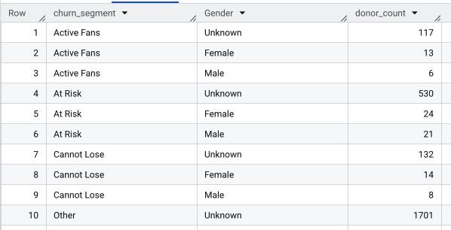

* + 1. **Gender vs Churn Segment - In-App**

**Query:**

SELECT

iseg.inapp_rfm_segment AS churn_segment,

c.Gender,

COUNT(*) AS customer_count

FROM `mis784-sem1.Assignment_3.v_inapp_segment` iseg

JOIN `mis784-sem1.Assignment_3.Customers` c

ON iseg.Customer_ID = c.Customer_ID

GROUP BY churn_segment, c.Gender

ORDER BY churn_segment, customer_count DESC;

**Result:**

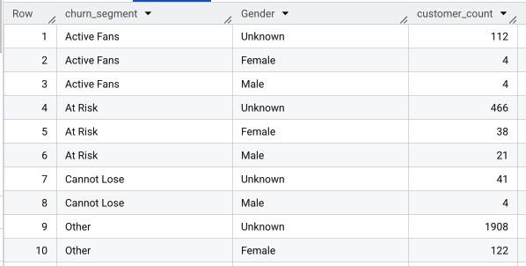

* + 1. **Income vs Churn Segment - Traditional Donors**

**Query:**

SELECT

ds.donation_rfm_segment AS churn_segment,

c.Income_Level,

COUNT(*) AS donor_count,

ROUND(100.0 * COUNT(*) / SUM(COUNT(*)) OVER (PARTITION BY ds.donation_rfm_segment), 2) AS pct_within_segment

FROM `mis784-sem1.Assignment_3.v_donation_segment` ds

JOIN `mis784-sem1.Assignment_3.Customers` c

ON ds.Customer_ID = c.Customer_ID

WHERE c.Income_Level IS NOT NULL

GROUP BY churn_segment, c.Income_Level

ORDER BY churn_segment, pct_within_segment DESC;

**Result:**

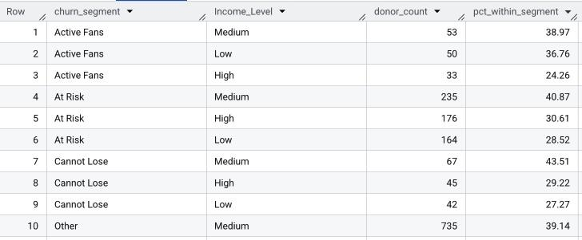

* + 1. **Income vs Churn Segment - In-App**

**Query:**

SELECT

iseg.inapp_rfm_segment AS churn_segment,

c.Income_Level,

COUNT(*) AS customer_count,

ROUND(100.0 * COUNT(*) / SUM(COUNT(*)) OVER (PARTITION BY iseg.inapp_rfm_segment), 2) AS pct_within_segment

FROM `mis784-sem1.Assignment_3.v_inapp_segment` iseg

JOIN `mis784-sem1.Assignment_3.Customers` c

ON iseg.Customer_ID = c.Customer_ID

WHERE c.Income_Level IS NOT NULL

GROUP BY churn_segment, c.Income_Level

ORDER BY churn_segment, pct_within_segment DESC;

**Result:**

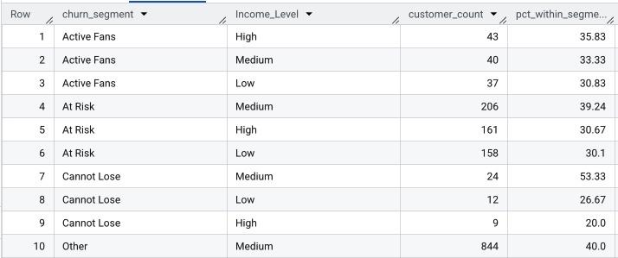

* + 1. **Family Size vs Churn Segment – Traditional Donor**

**Query:**

SELECT

dseg.donation_rfm_segment AS churn_segment,

ROUND(AVG(SAFE_CAST(c.Family_Size AS FLOAT64)), 2) AS avg_family_size,

COUNT(*) AS donors_in_segment

FROM `mis784-sem1.Assignment_3.v_donation_segment` dseg

JOIN `mis784-sem1.Assignment_3.Customers` c

ON dseg.Customer_ID = c.Customer_ID

WHERE SAFE_CAST(c.Family_Size AS FLOAT64) IS NOT NULL

GROUP BY churn_segment

ORDER BY avg_family_size DESC;

**Result:**

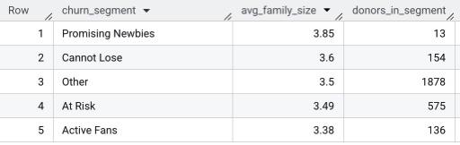

* + 1. **Family Size vs Churn Segment - In-App**

**Query:**

SELECT

iseg.inapp_rfm_segment AS churn_segment,

ROUND(AVG(SAFE_CAST(c.Family_Size AS FLOAT64)), 2) AS avg_family_size,

COUNT(*) AS customers_in_segment

FROM `mis784-sem1.Assignment_3.v_inapp_segment` iseg

JOIN `mis784-sem1.Assignment_3.Customers` c

ON iseg.Customer_ID = c.Customer_ID

WHERE SAFE_CAST(c.Family_Size AS FLOAT64) IS NOT NULL

GROUP BY churn_segment

ORDER BY avg_family_size DESC;

**Result:**

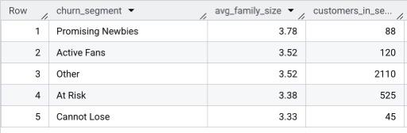

### Revenue Optimisation

-- reusable views

-- donations – aggregates and rfm

CREATE OR REPLACE VIEW `mis784-466303.A3.v_donation_agg` AS

WITH asof AS (

SELECT MAX(DonationDate) AS as_of

FROM `mis784-466303.A3.tradition_donation_patterns`

WHERE DonationDate IS NOT NULL)

SELECT

t.Customer_ID,

MAX(t.DonationDate) AS last_donation_date,

COUNT(*) AS donation_frequency,

SUM(t.DonationAmount) AS donation_total_amount,

DATE_DIFF((SELECT as_of FROM asof), MAX(t.DonationDate), DAY) AS days_since_last_donation

FROM `mis784-466303.A3.tradition_donation_patterns` t

WHERE t.DonationDate IS NOT NULL AND t.DonationAmount IS NOT NULL

GROUP BY t.Customer_ID;

CREATE OR REPLACE VIEW `mis784-466303.A3.v_donation_rfm` AS

SELECT

a.*,

NTILE(5) OVER (ORDER BY a.days_since_last_donation DESC, a.Customer_ID) AS R_score,

NTILE(5) OVER (ORDER BY a.donation_frequency ASC, a.Customer_ID) AS F_score,

NTILE(5) OVER (ORDER BY a.donation_total_amount ASC, a.Customer_ID) AS M_score

FROM `mis784-466303.A3.v_donation_agg` a;

CREATE OR REPLACE VIEW `mis784-466303.A3.v_donation_segment` AS

SELECT

Customer_ID,

CASE

WHEN R_score IN (4,5) AND F_score = 5 AND M_score = 5 THEN 'Cannot Lose'

WHEN R_score = 5 AND F_score IN (4,5) AND M_score IN (3,4,5) THEN 'Active Fans'

WHEN R_score = 5 AND F_score IN (2,3) AND M_score IN (4,5) THEN 'Promising Newbies'

WHEN R_score IN (3,4,5) AND F_score IN (2,3,4) AND M_score IN (2,3,4) THEN 'At Risk'

ELSE 'Other'

END AS donation_rfm_segment

FROM `mis784-466303.A3.v_donation_rfm`;

-- in-app – aggregates and rfm

CREATE OR REPLACE VIEW `mis784-466303.A3.v_inapp_agg` AS

WITH asof AS (

SELECT MAX(LastPurchaseDate) AS as_of

FROM `mis784-466303.A3.mobile_game_inapp_purchases`

WHERE LastPurchaseDate IS NOT NULL)

SELECT

m.Customer_ID,

MAX(m.LastPurchaseDate) AS last_purchase_date,

COUNTIF(m.InAppPurchaseAmount IS NOT NULL) AS purchase_frequency,

SUM(IFNULL(m.InAppPurchaseAmount,0)) AS purchase_total_amount,

DATE_DIFF((SELECT as_of FROM asof), MAX(m.LastPurchaseDate), DAY) AS days_since_last_purchase

FROM `mis784-466303.A3.mobile_game_inapp_purchases` m

WHERE m.LastPurchaseDate IS NOT NULL

GROUP BY m.Customer_ID;

CREATE OR REPLACE VIEW `mis784-466303.A3.v_inapp_rfm` AS

SELECT

a.*,

NTILE(5) OVER (ORDER BY a.days_since_last_purchase DESC, a.Customer_ID) AS R_score,

NTILE(5) OVER (ORDER BY a.purchase_frequency ASC, a.Customer_ID) AS F_score,

NTILE(5) OVER (ORDER BY a.purchase_total_amount ASC, a.Customer_ID) AS M_score

FROM `mis784-466303.A3.v_inapp_agg` a;

CREATE OR REPLACE VIEW `mis784-466303.A3.v_inapp_segment` AS

SELECT

Customer_ID,

CASE

WHEN R_score IN (4,5) AND F_score = 5 AND M_score = 5 THEN 'Cannot Lose'

WHEN R_score = 5 AND F_score IN (4,5) AND M_score IN (3,4,5) THEN 'Active Fans'

WHEN R_score = 5 AND F_score IN (2,3) AND M_score IN (4,5) THEN 'Promising Newbies'

WHEN R_score IN (3,4,5) AND F_score IN (2,3,4) AND M_score IN (2,3,4) THEN 'At Risk'

ELSE 'Other'

END AS inapp_rfm_segment

FROM `mis784-466303.A3.v_inapp_rfm`;

-- campaigns – dedup customer+campaign and attach campaign type

CREATE OR REPLACE VIEW `mis784-466303.A3.v_campaign_resp_dedup` AS

SELECT

Customer_ID, Campaign_ID,

MAX(Response) AS any_response,

AVG(IFNULL(ClickThroughRate,0)) AS avg_ctr_per_person,

AVG(IFNULL(EngagementFrequency,0)) AS avg_eng_per_person

FROM `mis784-466303.A3.campaign_response`

GROUP BY Customer_ID, Campaign_ID;

CREATE OR REPLACE VIEW `mis784-466303.A3.v_campaign_kpi_person` AS

SELECT

r.Customer_ID,

r.Campaign_ID,

m.CampaignType,

r.any_response,

r.avg_ctr_per_person,

r.avg_eng_per_person

FROM `mis784-466303.A3.v_campaign_resp_dedup` r

JOIN `mis784-466303.A3.marketing_campaigns` m USING (Campaign_ID);

-- unified rfm view

CREATE OR REPLACE VIEW `mis784-466303.A3.v_rfm_union` AS

SELECT

'donations' AS domain,

d.Customer_ID,

d.last_donation_date AS last_txn_date,

d.days_since_last_donation AS days_since_last,

d.donation_frequency AS frequency,

d.donation_total_amount AS total_amount,

d.R_score, d.F_score, d.M_score,

s.donation_rfm_segment AS segment

FROM `mis784-466303.A3.v_donation_rfm` d

JOIN `mis784-466303.A3.v_donation_segment` s USING (Customer_ID)

UNION ALL

SELECT

'inapp' AS domain,

i.Customer_ID,

i.last_purchase_date AS last_txn_date,

i.days_since_last_purchase AS days_since_last,

i.purchase_frequency AS frequency,

i.purchase_total_amount AS total_amount,

i.R_score, i.F_score, i.M_score,

s.inapp_rfm_segment AS segment

FROM `mis784-466303.A3.v_inapp_rfm` i

JOIN `mis784-466303.A3.v_inapp_segment` s USING (Customer_ID);

-- donor behaviour profiling

-- unified rfm breakdown

SELECT

'inapp' AS domain,

d.Customer_ID,

d.last_purchase_date AS last_txn_date,

d.days_since_last_purchase AS days_since_last,

d.purchase_frequency AS frequency,

ROUND(d.purchase_total_amount,2) AS total_amount,

d.R_score, d.F_score, d.M_score,

s.inapp_rfm_segment AS segment,

FROM `mis784-466303.A3.v_inapp_rfm` d

JOIN `mis784-466303.A3.v_inapp_segment` s USING (Customer_ID)

UNION ALL

SELECT

'donations' AS domain,

d.Customer_ID,

d.last_donation_date AS last_txn_date,

d.days_since_last_donation AS days_since_last,

d.donation_frequency AS frequency,

ROUND(d.donation_total_amount,2) AS total_amount,

d.R_score, d.F_score, d.M_score,

s.donation_rfm_segment AS segment,

FROM `mis784-466303.A3.v_donation_rfm` d

JOIN `mis784-466303.A3.v_donation_segment` s USING (Customer_ID)

ORDER BY domain, R_score DESC, F_score DESC, M_score DESC, total_amount DESC;

-- unified rfm segment sizes and value

SELECT

domain,

segment,

COUNT(*) AS num_customers,

ROUND(SUM(total_amount),2) AS segment_total_amount,

ROUND(AVG(total_amount),2) AS avg_amount_per_customer,

ROUND(AVG(frequency),2) AS avg_frequency

FROM `mis784-466303.A3.v_rfm_union`

GROUP BY domain, segment

ORDER BY domain, segment_total_amount DESC;

-- revenue optimisation

-- monthly/seasonal trends by product (donations)

SELECT

FORMAT_DATE('%Y-%m', DATE_TRUNC(DonationDate, MONTH)) AS month,

Product AS product_type,

COUNT(*) AS num_transactions,

ROUND(SUM(DonationAmount),2) AS total_amount,

ROUND(AVG(DonationAmount),2) AS average_amount

FROM `mis784-466303.A3.tradition_donation_patterns`

WHERE DonationDate IS NOT NULL AND DonationAmount IS NOT NULL

GROUP BY month, product_type

ORDER BY month, product_type;

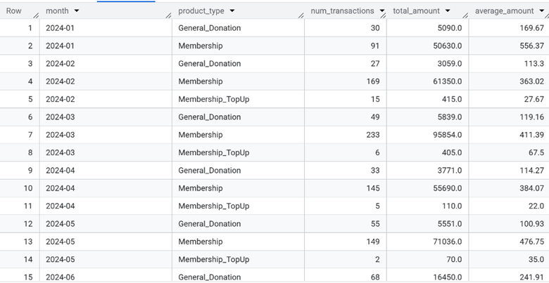

-- high-value contributors (top 5%) across both domains

WITH don_b AS (

SELECT APPROX_QUANTILES(DonationAmount,100)[OFFSET(95)] AS p95

FROM `mis784-466303.A3.tradition_donation_patterns`

WHERE DonationAmount IS NOT NULL),

inapp_b AS (

SELECT APPROX_QUANTILES(InAppPurchaseAmount,100)[OFFSET(95)] AS p95

FROM `mis784-466303.A3.mobile_game_inapp_purchases`

WHERE InAppPurchaseAmount IS NOT NULL),

u AS (

SELECT 'donations' AS domain, Customer_ID, DonationAmount AS amount

FROM `mis784-466303.A3.tradition_donation_patterns`

WHERE DonationAmount IS NOT NULL

UNION ALL

SELECT 'inapp' AS domain, Customer_ID, InAppPurchaseAmount AS amount

FROM `mis784-466303.A3.mobile_game_inapp_purchases`

WHERE InAppPurchaseAmount IS NOT NULL AND LastPurchaseDate IS NOT NULL)

SELECT

domain,

COUNT(*) AS hv_txn,

ROUND(SUM(amount),2) AS hv_total_amount,

ROUND(AVG(amount),2) AS hv_avg_amount

FROM u, don_b, inapp_b

WHERE (domain = 'donations' AND amount >= don_b.p95) OR (domain = 'inapp' AND amount >= inapp_b.p95)

GROUP BY domain

ORDER BY hv_total_amount DESC;

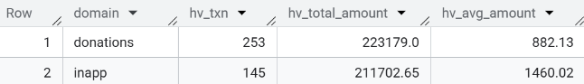

-- game genre x device performance (in-app) – revenue + engagement

SELECT

IFNULL(GameGenre,'Missing') AS game_type,

IFNULL(Device,'Missing') AS device_type,

COUNT(*) AS txn_count,

ROUND(SUM(IFNULL(InAppPurchaseAmount,0)),2) AS total_revenue,

ROUND(AVG(SessionCount),2) AS avg_sessions,

ROUND(AVG(AverageSessionLength),2) AS avg_session_minutes

FROM `mis784-466303.A3.mobile_game_inapp_purchases`

GROUP BY game_type, device_type

ORDER BY total_revenue DESC;

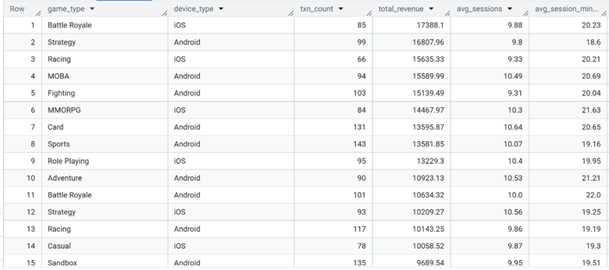

-- campaign effectiveness by type and audience

WITH camp_kpi AS (

SELECT

Campaign_ID,

AVG(IF(any_response, 1, 0)) AS response_rate,

AVG(avg_ctr_per_person) AS ctr,

AVG(avg_eng_per_person) AS engagement

FROM `mis784-466303.A3.v_campaign_kpi_person`

GROUP BY Campaign_ID)

SELECT

m.CampaignType AS campaign_type,

m.TargetAudience AS audience,

COUNT(*) AS num_campaigns,

ROUND(AVG(k.response_rate), 2) AS avg_response_rate,

ROUND(AVG(k.ctr), 2) AS avg_ctr,

ROUND(AVG(k.engagement), 2) AS avg_engagement,

ROUND(SUM(m.CampaignBudget), 2) AS total_budget

FROM `mis784-466303.A3.marketing_campaigns` m

LEFT JOIN camp_kpi k USING (Campaign_ID)

GROUP BY campaign_type, audience

ORDER BY avg_response_rate DESC, avg_engagement DESC;

-- campaign response by donation rfm segment and campaign type

SELECT

s.donation_rfm_segment,

p.CampaignType AS campaign_type,

ROUND(AVG(IF(p.any_response,1,0)),2) AS response_rate,

ROUND(AVG(p.avg_ctr_per_person),2) AS avg_ctr,

ROUND(AVG(p.avg_eng_per_person),2) AS avg_engagement

FROM `mis784-466303.A3.v_campaign_kpi_person` p

JOIN `mis784-466303.A3.v_donation_segment` s USING (Customer_ID)

GROUP BY s.donation_rfm_segment, campaign_type

ORDER BY s.donation_rfm_segment, response_rate DESC;

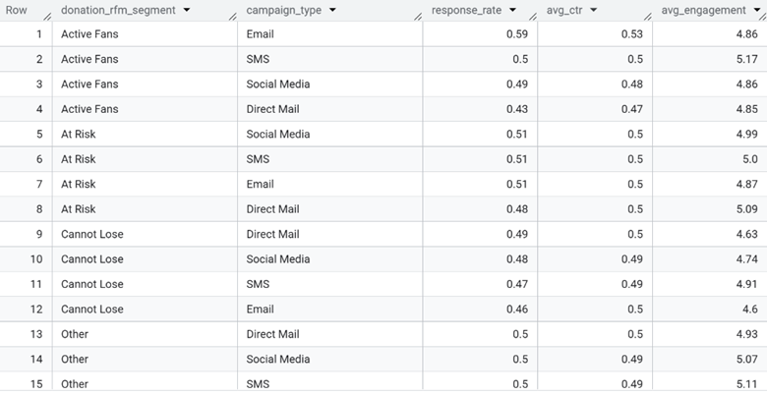

-- campaign cost per engaged person by campaign type

-- calculates both cost per unique engaged person and cost per engagement

WITH joined AS (

SELECT

m.CampaignType,

m.Campaign_ID,

m.CampaignBudget,

p.Customer_ID,

p.any_response

FROM `mis784-466303.A3.marketing_campaigns` m

LEFT JOIN `mis784-466303.A3.v_campaign_kpi_person` p USING (Campaign_ID)),

agg AS (

SELECT

CampaignType,

ROUND(SUM(CampaignBudget), 2) AS total_budget,

SUM(IF(any_response, 1, 0)) AS total_engagements,

COUNT(DISTINCT IF(any_response, Customer_ID, NULL)) AS engaged_people_unique

FROM joined

GROUP BY CampaignType)

SELECT

CampaignType,

total_budget,

total_engagements,

engaged_people_unique,

ROUND(SAFE_DIVIDE(total_budget, NULLIF(engaged_people_unique, 0)), 2) AS cost_per_unique_engaged,

ROUND(SAFE_DIVIDE(total_budget, NULLIF(total_engagements, 0)), 2) AS cost_per_engagement

FROM agg

ORDER BY cost_per_unique_engaged ASC;

## Meeting Minute

### Meeting Minute 1

| **Unit Code:** | | MIS784 Marketing Analytics T2 2025 | | |
| --- | --- | --- | --- | --- |
| **Assignment Group Number:** | | Group 60 | | |
| **Meeting attended by:** | | · Jayseon Choi  · Simran Thakur  · Lee Hoang | | |
| **Absent from meeting:** | | None | | |
| **Date:** | | 2025/9/14 | | |
| **Time:** | | 5:00pm-5:45pm | | |
|  | | | | |
| **Meeting Agenda #1: Introduction** | | | | |
| **Note:** team members introduce themselves | | | | |
|  | | | | |
| **Meeting Agenda #2: Assignment Discussion** | | | | |
| **Note:** go through the group assignment description together to ensure that all group members are familiar with the requirements of the assignment. | | | | |
|  | | | | |
| **Meeting Agenda #3: Division of Work** | | | | |
| **Note**: assign work contents to each group member for further assignment progress. | | | | |
|  | | | | |
| **Action items** | | | | |
| **Task** | **Status** | | **Who** | **Due by** |
| Identify patterns of donor behaviour  Analyse donor churn  Guide future donation activities |  | | Lee    Simran  Jayseon | Sunday (21/09/2025) |
|  | | | | |
| **Agenda for the next meeting:** | | · Pitch each member’s analysis  · Discuss the analysis  · Discuss the 4th (main requirement)  · By Thursday (18/09): Flag data quality to the team via the chat channel (no meeting) | | |
|  | | | | |
| **Adjournment** | | | | |
| · Adjourned at: 2025/9/18 8:51pm  · Next meeting will be held at: 2025/09/21 5:00-6:00pm | | | | |
|  | | | | |
| **Minute submitted by:** | | Lee Hoang | | |
|  | | | | |
| **Approved by:** | | Simran Thakur  Jayseon | | |

### Meeting Minute 2

| **Unit Code:** | | MIS784 Marketing Analytics T2 2025 | | |
| --- | --- | --- | --- | --- |
| **Assignment Group Number:** | | Group 60 | | |
| **Meeting attended by:** | | · Jayseon Choi  · Simran Thakur  · Lee Hoang | | |
| **Absent from meeting:** | | None | | |
| **Date:** | | 2025/9/28 | | |
| **Time:** | | 6:00pm-6:45pm | | |
|  | | | | |
| **Meeting Agenda #1: Summary of individual analysis** | | | | |
| **Note:** | | | | |
|  | | | | |
| **Meeting Agenda #2: Consolidate individual’s analysis to make the analysis section consistent** | | | | |
| **Note:** | | | | |
|  | | | | |
| **Action items** | | | | |
| **Task** | **Status** | | **Who** | **Due by** |
| Fix rfm and rerun churn    All team members to finalise analysis |  | | Jayseon and Simran | 29/09/2025    30/09/2025 |
|  | | | | |
| **Agenda for the next meeting:** | | · Recommendations | | |
|  | | | | |
| **Adjournment** | | | | |
| · Adjourned at: 2025/9/28 8:25 pm  · Next meeting will be held at: to be finalized once analysis is done | | | | |
|  | | | | |
| **Minute submitted by:** | | Lee Hoang | | |
|  | | | | |
| **Approved by:** | | Simran Thakur  Jayseon | | |

### Meeting Minute 3

| **Unit Code:** | | MIS784 Marketing Analytics T2 2025 | | |
| --- | --- | --- | --- | --- |
| **Assignment Group Number:** | | Group 60 | | |
| **Meeting attended by:** | | · Jayseon Choi  · Simran Thakur  · Lee Hoang | | |
| **Absent from meeting:** | | None | | |
| **Date:** | | 2025/10/01 | | |
| **Time:** | | 7:10pm-7:25pm | | |
|  | | | | |
| **Meeting Agenda #1: Finalise analysis** | | | | |
|  | | | | |
| **Meeting Agenda #2: Discuss recommendations** | | | | |
|  | | | | |
| **Action items** | | | | |
| **Task** | **Status** | | **Who** | **Due by** |
| Personalized outreach  Predictive Retention Model  App-based incentives |  | | Lee    Simran    Jayseon | Friday (03/10/2025) |
|  | | | | |
| **Agenda for the next meeting:** | | N/A | | |
|  | | | | |
| **Adjournment** | | | | |
| Adjourned at: 2025/10/01 7:25pm | | | | |
|  | | | | |
| **Minute submitted by:** | | Lee Hoang | | |
|  | | | | |
| **Approved by:** | | Simran Thakur  Jayseon | | |